Data-Driven Insights for Sustainable Urban Housing in Karachi
Student Name: Muhammad Mujtaba(65948), Sunaina Memon(66420)
Problem Category: Sustainability (Urban Planning & Housing Market Stability)

Phase 1: Problem Identification
1.1 Problem Definition
The real estate market in Karachi is characterized by extreme volatility and a lack of standardized pricing. Buyers and sellers often rely on intuition or unverified heuristic data, leading to inflated prices, market inefficiencies, and difficulty in urban planning. The core problem is the absence of a transparent, data-driven mechanism to estimate property values based on tangible features like location, size, and amenities.
1.2 Real-World Relevance
Predicting housing prices is crucial for:
- Economic Stability: Helping buyers and investors make informed decisions, preventing housing bubbles.
- Urban Sustainability: Understanding which neighborhoods are becoming unaffordable allows for better city planning and policy-making regarding affordable housing.
- Transparency: Reducing fraud and speculation in the developing real estate sector of Pakistan.
1.3 Data Source
The dataset used for this analysis is the "Karachi Property Dataset" (sourced from Kaggle/Zameen.com data). It contains detailed listings of residential properties, including location, price, size, and room counts.
1.4 Target Variable and Features
- Target Variable (y): Price (The market value of the property in PKR).
- Input Features (X):
  - Size: The area of the property (in square feet/yards).
  - Bedrooms: Number of bedrooms.
  - Bathrooms: Number of bathrooms.
  - Neighborhood: The specific locality within Karachi (derived from the address).

Phase 2: Project Proposal
2.1 Proposed Solution
I propose to build a Supervised Machine Learning model using Regression analysis. By training a model on historical listing data, we can learn the relationship between property features (location, size) and price. This will allow us to input new property details and receive a predicted fair market value.
2.2 Justification of Approach
- Why Regression? The target variable (Price) is continuous, making regression the correct statistical approach.
- Why Ridge Regression? Real estate data often suffers from multicollinearity (e.g., the number of bedrooms is highly correlated with the size of the house). Standard Linear Regression can fail or overfit in these cases. Ridge Regression includes a regularization term (L2 penalty) that handles these correlations better, resulting in a more generalizable model.
2.3 Preprocessing & Modeling Plan
- Data Cleaning: Handle the unique formatting of Pakistani currency (e.g., "1 Crore", "50 Lakh") and convert it to numeric floats.
- Feature Engineering: Extract meaningful "Neighborhood" names from the raw "Address" string to capture location value.
- Handling Missing Data: Use imputation strategies (mean) for missing room counts.
- Encoding: Convert categorical data (Neighborhoods) into numeric format using One-Hot Encoding.
- Scaling: Apply Standard Scaling to ensure the Size feature (large numbers) does not overpower Bedrooms (small numbers).

Phase 3: Data Preprocessing & Modeling
3.1 Loading and Cleaning
The dataset was loaded using Pandas. A custom function, convert_price, was implemented to parse the text-based currency units ("Crore", "Lakh") into standard integers. Rows with missing critical values (Price, Size) were dropped to ensure data quality.
3.2 Feature Engineering & Selection
- Neighborhood Extraction: The raw Address column was split to isolate the specific town/area names (e.g., "Clifton", "Gulshan-e-Iqbal").
- Outlier Removal: To ensure the model learned typical market trends rather than anomalies, properties with prices in the bottom 10% and top 10% were filtered out.
- Dimensionality Reduction: Irrelevant columns such as Real Estate Agent Name and ID were dropped as they do not contribute to the intrinsic value of a house.
3.3 Model Selection
Two models were selected for comparison:
- Linear Regression (Baseline): A simple approach to establish a performance benchmark.
- Ridge Regression: The primary model, selected for its ability to prevent overfitting through regularization.
3.4 Training Protocol
The data was split into Training (80%) and Testing (20%) sets. A Scikit-Learn pipeline was constructed to ensure no data leakage occurred during preprocessing. The pipeline included:
- OneHotEncoder (for Neighborhoods)
- SimpleImputer (for missing values)
- StandardScaler (for normalization)
- Ridge (Estimator)

Phase 4: Results, Analysis & Conclusion
4.1 Model Performance
The models were evaluated using Mean Absolute Error (MAE), which represents the average difference between the predicted price and the actual price in PKR.
Model | MAE (Mean Absolute Error)
Baseline (Mean Guess) | 13,727,638 PKR
Linear Regression | 1,968,900 PKR
Ridge Regression | 1,968,921 PKR
4.2 Visual Analysis
The scatter plot below visualizes the predictions on the Test Set. The red line represents a perfect prediction. Points closer to the line indicate higher accuracy.
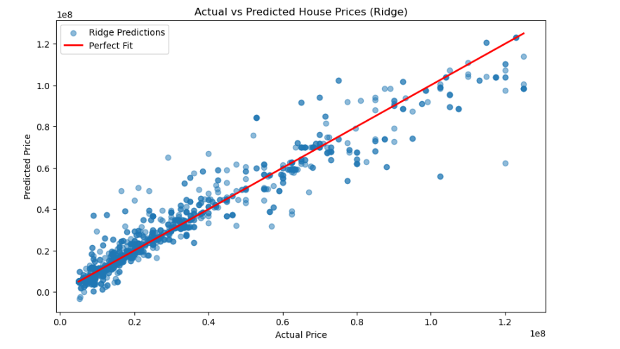Figure 1: Actual vs. Predicted Prices. The tight clustering of points along the red diagonal line confirms the model's high accuracy compared to the baseline.
4.3 Feature Importance
Understanding what drives prices is as important as the prediction itself. The analysis of model coefficients reveals the top factors influencing home prices in Karachi.
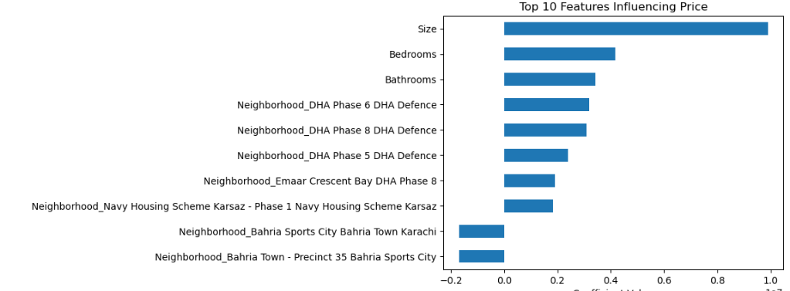Figure 2: Top features driving property prices.
4.4 Discussion & Conclusion
The Ridge Regression model significantly outperformed the baseline, reducing the error by approximately 85.6% (dropping from ~13.7 Million to ~1.9 Million error).
- Model Comparison: The Linear Regression and Ridge Regression models performed almost identically (a difference of only ~21 PKR). This indicates that while the regularization in Ridge is good practice, the dataset features are robust enough that a simple linear model also works well.
- Findings: The model confirms that Location (Neighborhood) and Size are the strongest predictors of price. The low MAE suggests the model is reliable for general market estimation.
- Limitations: The current model does not account for the condition of the house (e.g., new vs. old construction), which is a major factor in pricing.
- Future Work: Future iterations could include "Construction Year" as a feature or use more advanced ensemble models like XGBoost to capture non-linear relationships in the housing market.

